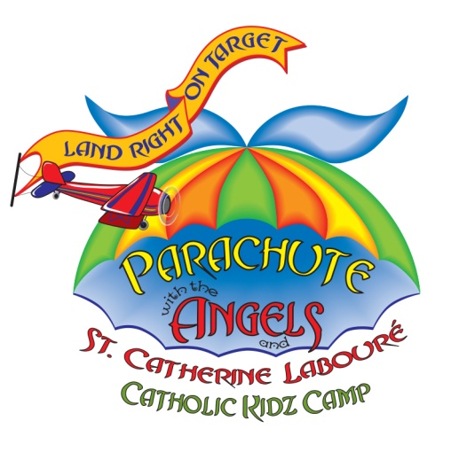PA Multi-Border colorPA Multi-Border colorPA Multi-Border colorPA Multi-Border colorPA Multi-Border colorPA Multi-Border color

**Contact:**

**Name:**

**Phone:**

**E-mail:**

Registration fee per child @ x = $

Reserve my *Angel of God* Music CD @ 5.99 x = $

Reserve my *St. Catherine Labouré* Storybook @ 8.99 x = $

I have enclosed a check in the amount of TOTAL $

***GOD IS YOUR PILOT DURING  
FUN-FILLED DAYS   
OF CATHOLIC KIDZ CAMP***

**Dates: Times:**

**Location:**

**Another NEW and Exciting Catholic Kidz Camp   
from Growing with the Saints!**

✂

*Check in with St. Catherine,   
pick-up your flightplan   
and meet your Co-Pilot:   
Your very own Guardian Angel!*

*Visit Growing with the Saints at* **www.growingwiththesaints.com** *for more Saint Series books for children.*

© Growing with the Saints, Inc. - Permission to alter and copy for your program granted.

|  |  |  |  |
| --- | --- | --- | --- |
| **Prek/K 4-up** | **Grades 1-2** | **Grades 3-4** | **Grades 5-6** |
|  |  |  |  |
|  |  |  |  |
|  |  |  |  |

Can you volunteer to help?

Child’s Name:

Child’s Name:

Child’s Name:

Parent Name:

Address:

Phone:

City: State: Zip: